Access Technology for Persons with Vision Impairment and Blindness
Basic Modifications of AT for Persons with Visual Impairment
Technology for persons with visual impairment is typically divided into 4 main categories, each of which either creates an alternative sensory input or augments existing vision. These categories are:
- Enhanced Image.
- Speech.
- Braille.
- Optical Character Recognition.
Devices from these categories can be used separately on in combinations to assist the person with a visual impairment access information.

Enhanced Image
Over 90% of the persons categorized as visually impaired have some vision (Doherty, 1993). Persons with limited vision will often want to use their residual vision. Enhanced images allow these individuals, through technology to use existing visual abilities.
Images can be enhanced two ways.
1. Magnification technology enlarges the visual image to accommodate the limited visual abilities of the person. Magnification can be accomplished using either low-tech or high-tech devices. If high-tech systems are used, these will involve both hardware and software components.

Technology for Magnification
To learn more about technology for magnification, visit these sites:
Magnification for persons with visual impairment
Can You Read This?

Examples of the different types of magnification:
Skim through these links to learn about the different types of magnification we can provide for persons with low vision:
Closed Circuit Televisions (CCTV)
Software-based magnification programs:
Ai Squared (www.aisquared.com) try downloaded the demo software for trial
Hand-held magnifiers and binoculars:
MaxiAids (www.maxiaids.com)
Glasses (http://www.ocutech.com/products.html) and other resources
2. High Contrasting
For some individuals with vision impairment, it is difficult to separate foreground and background information. A way to assist this person would be to alter the contrast value of the material. The most typical contrast change is inverse imaging. Other variations involve using different colored paper and text. Another strategy for altering contrast values is to provide additional lighting for the subject matter.
Examples of altering contrast:
High contrast lighting (http://www.dazor.com/)
LS & S Group (http://www.lssgroup.com/)

Top of Form
Speech.
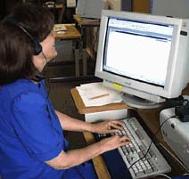 | A second method of modifying tasks for persons with vision impairment is to convert information that is presented visually into an auditory form. For example, the time, as indicated by the hands of a clock, is converted to speech output ("It is 8:00 pm"). The method for accomplishing this is called speech synthesis. Persons who have severely limited vision or who are blind often use speech as a primary means of accessing printed material. Sometimes, persons with limited vision, who use magnification as their primary modification, will use speech as a backup method when the information presented in a visual form is difficulty to interpret.
Speech Access (skim through)
Speech access can take two forms:
- Synthesized Speech
- Recorded Speech
Examples of speech synthesis and recorded speech devices:
Speech Synthesis:
JAWS
ZoomText Plus
The Reading Edge
Kurzweil 1000

Braille
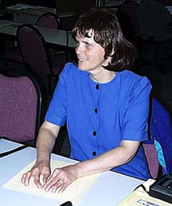 | Braille is a third type of modification for persons who have severely limited vision or who are blind. Braille capitalizes on a person's tactile abilities by presenting information in sets of raised dots (Braille cells) that can be read by moving your fingers across the Brailled page. It should be noted that only about 15% of persons who are blind are literate in Braille.
Skim through the following online resources:
Braille Input
Braille Monitoring
Braille Output

Examples of Braille Technology:
Braille Display
Braille Printers/Embossers

Braille Notetakers are devices used across a variety of environments by person with vision impairment and blindness. They function similar to a laptop computer, but include many of the features you would find in a Personal Digital Assistant (PDA). Look at some of these examples of this type of technology.
Braille Notetakers

Optical Character Recognition
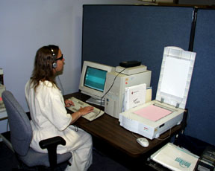
Optical Character Recognition (OCR) is a technology that is often used by persons with visual impairments to get information into a digital (computer) format. Once in a digital format, the person can either use magnification or speech to convert the text into an accessible format.
Optical Character Recognition
Examples of OCR Devices:

Combined Strategies
Often, AT devices for persons with visual impairment do not fit into discreet categories. For example, a Braille notetaker may combine speech and Braille input/output. Combined devices are typically high-tech devices.
Combined Technologies

